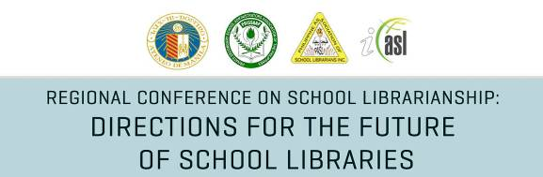

April 26-27, 2012
Bacolod City, Philippines

P R O G R A M M E

Day 1

9:00 – 10:00 am Opening Ceremonies
10:00 – 10:15 am Coffee Break
10:15 – 12:00 nn Paper Presentations 1-3: Reading and the School Library
12:00 – 1:00 pm Lunch Break
1:00 – 3:00 pm Workshop
3:00 – 3:15 pm Coffee Break
3:15 – 3:45 pm Paper Presentation 4: Library Space and Place Planning
3:45 – 5:00 pm Paper Presentation 5-6: Teacher-librarian Partnerships

Day 2

8:30 – 10:00 am Paper Presentations 7-9: Innovative Projects and Services
10:00 – 10:15 am Coffee Break
10:15 – 10:45 am Paper Presentation 10: Innovative Projects and Services
10:45 – 12:00 nn Paper Presentation 11-12: Information Literacy
12:00 – 1:00 pm Lunch Break
1:00 – 2:00 pm Paper Presentations 13-14: School Libraries/Librarians of the Future
2:00 – 3:00 pm Paper Presentations 15-16
3:00 – 3:15 pm Coffee Break
3:15 – 3:45 pm Paper Presentation 17
3:45 pm onwards Culminating/Closing Ceremonies

